Abstract Title (Bold, 16)
A. Author^{1*}, B. Author² and C. Author³
¹Affiliation and full address of A. Author
² Affiliation and full address of B. Author
³ Affiliation and full address of C. Author
* e-mail address of the corresponding author
This is a template for the preparation of the abstracts submitted to the International Conference on Hydrogen Horizons (ICH2). Formatting of text sizes and fonts (Arial 10) for the main body of the abstract), margins, spacing (simple), paragraphs, page, etc. have been chosen to normalize the final contents of the book of abstracts. Therefore, the organization thanks the authors for preparing the abstract following this structure, without changing the format parameters.
Keywords: Author should add 3-5 keywords.

INTRODUCTION
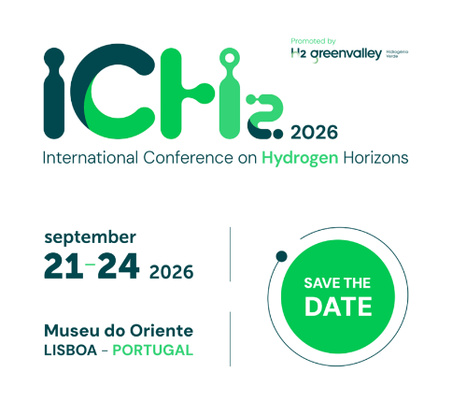
This document should be prepared in MS Word format. If you are pasting a prewriting text, chose the option “keep text only” when paste, writing later the special characters (Greek, symbols, super/subscript, etc.). The best option is to write directly in this template document, substituting the text of the sections. Please note that the spacing before and after the paragraph must maintain, and that the first line of the paragraph has an indentation of 5 mm.
All submission must be written in clear English.
The use of different sections should be as presented in the format indicates in this section, with the title using Heading 2 of this word document. Tables and figures can be aligned to the right margin, left margin, or expanded to the full width of the page (respecting the margins of the page).
Figure 1. Example of image and caption.

Methodology
The caption of figures and tables should be formatted in Arial 8. “Table x” and “Figure x” in the caption should be formatted in bold. For tables in MS Word documents, there will be several exceptions concerning the management of these kinds of objects, but the presentation should be as close as the one shown here. In any case, keep a minimum distance of ca. 4 mm to the main body of the text.

Table 1. Example of table and caption.

RESULTS AND DISCUSSION
The abstract must not exceed 2 pages including figures, tables and references.
There is no minimum extension but take into account that the acceptance of the communication will be based on the evaluation of the submitted abstract. If the description of the scientific/technological novelty, quality, and innovation of the work is poorly described, the acceptance possibilities, especially as an oral presentation, are scarce.
Abstracts exceeding two pages or not following the template format will be automatically rejected.

Conclusions
References should be cited in the text using consecutive numbers in square brackets (e.g., [1], [2–5]). The complete list of references must appear in a separate section titled “References”, ordered according to their first appearance in the text. The reference list should be formatted in Arial 10, with each reference numbered in square brackets. If reference management software (such as EndNote, Mendeley, or similar tools) is used to generate the bibliography, authors should ensure that the final document is submitted as plain text, with all field codes or links to external bibliographic databases removed.

ACKNOWLEDGEMENTS
The author should save the WORD file with the following name format:
ICH2_Abstract_FirstAuthorSurname.docx
All submissions will undergo peer review by the scientific committee.
Accepted abstracts will be published in the ICH2 Book of Abstracts.

REFERENCES
[1] Staffell, I., Scamman, D., Velazquez Abad, A., et al., The role of hydrogen and fuel cells in the global energy system. Energy & Environmental Science, 2019, 12, 463–491.
[2] Züttel, A., Hydrogen Storage: Methods and Materials. Springer, Berlin, 2008.
[3] International Energy Agency (IEA), The Future of Hydrogen: Seizing Today’s Opportunities. IEA Publications, Paris, 2019.
[4] European Commission, A Hydrogen Strategy for a Climate-Neutral Europe. Brussels, 2020.

